Curriculum vitae
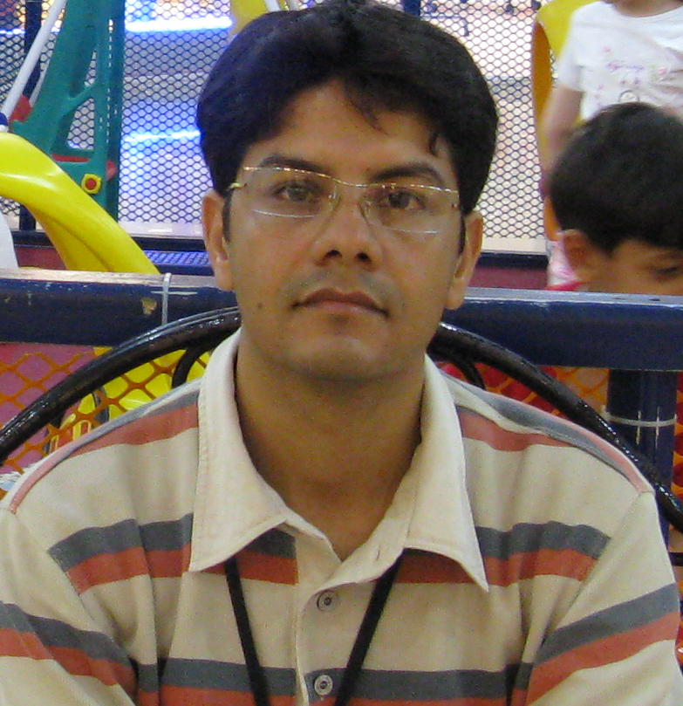
Personal data
Surname Ranjbar
Forename Mehdi
Date Birth 1978
Nationality Iranian
Marital Status Married, no child
Present address Department of Physics, Sharif University of Technology, Tehran, Iran, P.O.Box: 11365-9161.
Tel +982166164537-49
Fax +98 21 6602 2711
Email mranjbar@physics.sharif.edu
mehdi.ranjbar@gmail.com
Education
[2009 up to now] Postdoctoral Associate, Sharif University of Technology, Tehran, Iran
[2008] Ph.D. in Experimental physics, Sharif University of Technology, Tehran, Iran
Title: Preparation of tungsten oxide thin films and study of their gasochromic properties
Supervisor: Prof. A. Iraji zad

[2003] M.S. in Experimental physics, Sharif University of Technology, Tehran, Iran
Title: Study of surface and sputtering of electrochemical deposited Ni-Fe thin film
Supervisor: Prof. A. Iraji zad

[2000] B.S. in physics, Tarbiyat Moallem University, Tehran Iran.

Training
Nanotechnology
Methods for fabrication of nanostructure systems
Transmission Electron Microscope
Advanced concepts of solid state physics

Teaching Experience
[2003-2008] Teaching Assistant of Physics Lab I, Sharif University of Technology, Tehran, Iran

[2003-2008] Teaching Assistant of Physics Lab II, Sharif University of Technology, Tehran, Iran

[2004] Teacher of Quantum physics I, Azad University, Iran
Teacher of Analytical mechanics I, Azad University, Iran
Teacher of Electromagnetic I, Azad University, Iran
Teacher of Physics mathematics I, Azad University, Iran

Skills:
1- Over 3 years of experience in working with Ultra High Vacuum systems at ESCA/AES lab.
2- Over 5 years of experience with Deposition of thin films and nanostructures by especially Pulsed Laser Deposition technique.
3- Expert in XPS analysis of metal oxides.
4. Other techniques: AFM, SEM, TEM, UV-visible spectrophotometer

Language Skills
Persian Mother Tongue
English Good
Arabic Elementary

Computer Skills
Operating systems and software Windows, Office, XPS software, Origin,.
Ranks and awards 12th grad of Physics Olympiad for Mater of Science exam in Iran 2000 Tehran, Iran
9th award of business plan at Sharif University of technology

Favorites Fine observation of Nature

Publications in refereed journals

1. M. Ranjbar, M.M. Ahadian, A. Iraji zad and A. Dolati, ((The effect of the Cr and Mo on the surface accumulation of copper in the electrodeposited Ni–Fe/Cu alloy films)), Materials Science and Engineering: B 127 (2006), 17-21.

2. M. M. Ahadian, A. Iraji zad , E. Nouri, M. Ranjbar, A. Dolati, ((Diffusion and segregation of substrate copper in electrodeposited Ni-Fe thin films)), Journal of Alloys and Compounds 443 (2007) 81–86

3. M. Ranjbar, A. Iraji zad and S. M. Mahdavi, Gasochromic tungsten oxide thin films for optical hydrogen sensors, J. Phys. D: Applied Phys. 41 No 5 (2008) 055405 (5pp)

4. M. Ranjbar, S. M. Mahdavi and A. Iraji zad, Pulsed laser deposition of W–V–O composite films: Preparation, characterization and gasochromic studies, Solar Energy Materials & Solar Cells 92 (2008) 878– 883.

5. M. Ranjbar, A. Iraji zad and S. M. Mahdavi, Real-time measurement of oxidation dynamics of sub-stoichiometric tungsten oxide films by pulsed laser deposition, Appl Phys A (2008) 92: 627–634.

6. M. Ranjbar, N. Tahmasebi. G, S. M. Mahdavi and A. Iraji zad, Electroless plating of palladium on WO₃ films for gasochromic applications, under revising for Solar Energy Materials & Solar Cells (2009).

Proceeding and Conferences

1. M. Ranjbar, N. tahmasebi. G, A. Iraji zad and S. M. Mahdavi, ((Nanostructured tungsten oxide coatings as optical smart materials)), Accepted as oral presentation for SPIE Symposium on Smart Materials, 9-12 December 2008, Melbourne, Australia.
2. M. Ranjbar, A. Iraji zad and S. M. Mahdvai, ((preparation and characterization of tungsten oxide nanostructure for gasochromic applications)) 2nd Conference on Nanostructures (Ns 2008), March 11-14, Kish University, Kish Island, Iran.
3. M. Ranjbar, A. Iraji zad and S. M. Mahdvai, ((A new method for studding of surface desorption of oxygen in Pulsed Laser Deposition of tungsten oxide films in vacuum)), 3th Iranian Conference of Vacuum, (2008), Sharif University of Technology, Tehran, Iran.
4. M. Ranjbar, A. Iraji zad and S. M. Mahdvai, ((Pulsed Laser Deposition of tungsten oxide thin films)) 2nd International Workshop on Physics and Technology of Thin Films, June 26-30, (2006), Praha, Czech Republic. (Oral presentation)
5. M. Ranjbar, A. Iraji zad and A. Dolati, ((Surface segregation of copper and the effect of Cr and Mo on the magnetic Ni-Fe/Cu layers at room temperature)), the 8th annual congress of Iranian society of metallurgy engineering, (2003) Isfahan University of Technology, Isfahan, Iran.
6. M. Ranjbar, M. M. Ahadian, A. Iraji zad and A. Dolati ((Depth profile study of electrochemical deposited Ni-Fe on Cu and ITO/glass thin films)), Iranian annual physics conference, (2002) Yazd University, Yazd, Iran.
7. Participant of 1nd International Conference on Nanostructures (Ns 2006), Kish University, Kish Island, Iran.
8. Participant of 1nd International Workshop on Physics and Technology of Thin Films, (2004), Tehran, Iran.

